**ADVANCING COSMETIC INNOVATIONS THROUGH ORGANIC BIOMASS: A WEB APPLICATION FOR EFFICIENT BIOMASS CONVERSION INTO SUSTAINABLE FORMULATIONS**

**TABLE OF CONTENTS**

**1. SOFTWARE DEVELOPMENT LIFE CYCLE**

**2. PLATFORM KNOWLEDGE**

**3. DOMAIN KNOWLEDGE**

**4. ABOUT PROJECT**

4.1 ABSTRACT

4.2 SCOPE OF THE PROJECT

4.3 EXISTING SYSTEM

4.3.1 DISADVANTAGES

4.4 PROPOSED SYSTEM

4.4.1 ADVANTAGES

**5. BOTTOM LINE AND FUTURE ENHANCEMENT**

**6. SOFTWARE AND HARDWARE REQUIREMENTS**

**1. SDLC (Software Development Life Cycle)**

The Software Development Life Cycle is a systematic process for building software that ensures the quality and correctness of the software built. SDLC process aims to produce high-quality software which meets customer expectations. The software development should be completed within the pre-defined time frame and cost.

**SDLC Phases**

The entire SDLC process is divided into the following stages

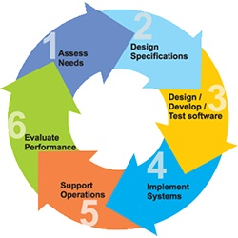

* Phase 1: Requirement gathering and analysis
* Phase 2:Fesability Study
* Phase 3: Design
* Phase 4: Coding
* Phase 5: Testing
* Phase 6: Installation/Deployment
* Phase 7: Maintenance

**2. PLATFORM KNOWLEDGE**

**Introduction to Java**

Java programming language was originally developed by Sun Microsystems which was initiated by James Gosling and released in 1995 as a core component of Sun Microsystems' Java platform. Initially, the language was called “Oak” but it was renamed as “Java” in 1995. The primary motivation of this language was the need for a platform-independent language. Finally, Java is for Internet Programming where C was to System Programming.

**Java architecture**

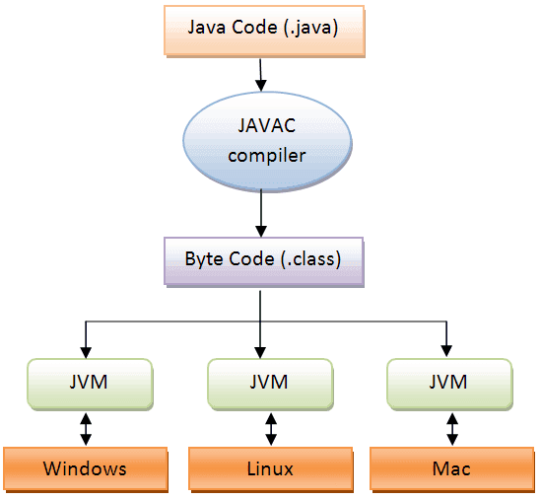Java is a high-level Object-oriented programming language. A program written in high level language cannot be run on any machine directly. First, it needs to be translated into that particular machine language. The javac compiler does this thing, it takes java program (.java file containing source code) and translates it into machine code (referred as byte code or .class file). Java Virtual Machine (JVM) is a virtual machine that resides in the real machine (your computer) and the machine language for JVM is byte code. JVM executes the byte code generated by compiler and produce output. JVM is the one that makes java platform independent.

**3. DOMAIN KNOWLEDGE**

**MACHINE LEARNING**

**OVERVIEW**

Machine learning is an application of Artificial Intelligence (AI) that provides systems the ability to automatically learn and improve experience without being explicitly programmed. Machine learning focuses on the development of computer programs that can access data and use it learn for themselves. The primary aim is to allow the computer to learn automatically without human intervention or assistance and adjust actions accordingly.

The test for a machine learning model is a validation error on new data not a theoretical test that proves a null hypothesis. Because this often uses an iterative approach to learn from data, the learning can be easily automated.

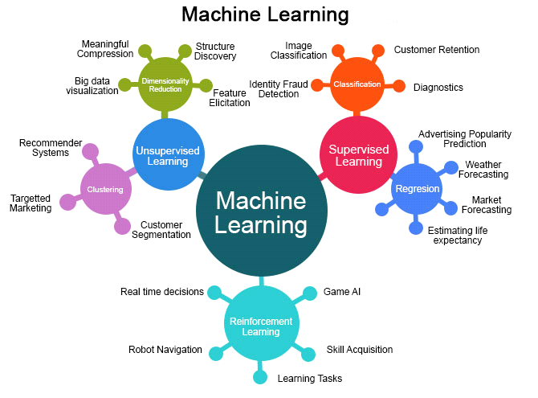

**MACHINE LEARNING METHODS**

Some of the methods of Machine Learning algorithm are categorized as

**SUPERVISED LEARNING**

A Supervised learning algorithm learns from labeled training data, helps you to predict outcomes for unforeseen data. It is highly accurate and trustworthy method.

**UNSUPERVISED LEARNING**

Unsupervised learning algorithm is the type of self - organized with the help of previously unknown patterns in dataset without pre-existing labels.

**SEMI-SUPERVISED LEARNING**

Semi-supervised learning is the combination of both supervised and unsupervised which means labeled and unlabeled data.

**REINFORCEMENT MACHINE LEARNING**

Reinforcement machine learning is an area of machine learning concerned with how software agents ought to take actions in an environment so as to maximize some notion of cumulative reward.

**APPLICATIONS OF MACHINE LEARNING**

* + Video Surveillance
  + Social Media Services
  + Email Spam and Malware Filtering
  + Financial Services
  + Health Care
  + Retail
  + Transportation

**ADVANTAGES**

* + Computational property is cheaper and more powerful.
  + Affordable data storage.
  + It can analysis complex data quickly and automatically.
  + It produces more accurate results.

**ADVANCING COSMETIC INNOVATIONS THROUGH ORGANIC BIOMASS: A WEB APPLICATION FOR EFFICIENT BIOMASS CONVERSION INTO SUSTAINABLE FORMULATIONS**

**4. ABOUT THE PROJECT**

**4.1 Abstract**

This project focuses on developing a web application that helps manage hair waste and transforms it into useful beauty and hair care products. Salons generate a significant amount of hair waste, which often ends up in landfills, causing environmental pollution. Our system provides a digital platform for salon owners and clients to track and process hair waste efficiently, ensuring a more sustainable and eco-friendly approach. The web application is designed with a user-friendly interface that allows salons to log hair waste collection, monitor its processing, and analyze its quality based on melanin and keratin levels. Melanin plays a crucial role in UV protection, while keratin strengthens hair care products. These two components are essential in the production of beauty items, making their extraction and processing highly valuable. By implementing machine learning techniques, the system ensures that the best processing method is chosen, optimizing the extraction process and enhancing product quality. Additionally, the web application facilitates better communication between salons and manufacturers, allowing for smoother transactions and real-time tracking of hair waste management. The system also generates detailed reports that provide insights into waste collection, processing efficiency, and overall impact on sustainability. This feature helps salon owners make informed decisions and adopt more environmentally friendly practices. By using this web application, salons can significantly reduce waste, contribute to a greener environment, and promote sustainability in the beauty industry. The project aims to bridge the gap between waste management and technological advancements, ensuring that hair waste is effectively repurposed rather than discarded. Future improvements of this project include refining the hair extraction process, scaling up production to accommodate more salons, and expanding the application’s functionalities. To improve decision-making and efficiency, the system utilizes a decision tree algorithm. This algorithm helps in selecting the best quality hair for different beauty and hair care products by analyzing data such as hair type, temperature treatment, and melanin-keratin content. Additional research will focus on exploring other potential uses of hair-derived melanin and keratin in various industries. This initiative holds great promise in revolutionizing salon waste management and integrating technology into the beauty industry for a more sustainable future.

**4.2 Scope of the Project**

The goal of this project is to create a web application that helps salons manage their hair waste and turn it into useful products like beauty and hair care items. Salons often throw away a lot of hair, which ends up in landfills, causing pollution. This web application will help salon owners and clients track and process the hair waste in an easy and eco-friendly way. The web app will have a simple interface where salons can log the hair they collect, track how it is processed, and check its quality. The app will measure important things like melanin (which helps protect against the sun) and keratin (which strengthens hair care products). These two ingredients are important for making beauty products, so it’s useful to get the best quality from the hair waste. To help with this, the app will use smart technology, like machine learning, to choose the best way to process the hair and get the highest quality melanin and keratin. The web app will also allow salons and manufacturers to communicate easily, making the process smoother. It will generate reports that show how well the system is working, helping salon owners make better decisions for a greener and more sustainable business. This project will help salons reduce waste, be more eco-friendly, and promote sustainability in the beauty industry. In the future, the app could be improved to handle more salons, improve the hair processing methods, and explore new ways to use melanin and keratin in other products. By using this system, the beauty industry can move towards a more environmentally conscious future. The project also aims to encourage salons to send their hair waste to be reused, rather than thrown away. This involves cleaning and preparing the hair so it can be used in making skincare products like sunscreens, which are in demand for their ability to protect the skin from the sun. By developing this web app and using technology to manage hair waste, we hope to create a solution that benefits both the environment and the beauty industry, while also making sure the whole process is easy and effective.

**4.3 Existing System**

The existing system involves extracting melanin and keratin from various sources, and using them to create beauty and hair care products. Currently, melanin is often extracted from different sources like fungi (such as Auricularia a and Phellinus linteus), cuttlefish ink, and even certain bacterial strains like Pseudomonas aeruginosa. Keratin is commonly extracted from animal-based sources like chicken feathers and sheep wool using chemical or enzymatic methods. However, there’s no complete system to track and manage the extraction process in salons. The lack of a structured process for handling salon waste highlights the need for creative solutions to reduce environmental impact. The web application would address this gap by providing a platform for salons to log and track their hair waste, monitor the extraction of melanin and keratin, and connect with manufacturers for further processing. The app would optimize the extraction process using smart technologies, enabling salons to reuse their waste efficiently. By managing the hair waste digitally, the system would help improve sustainability and reduce the beauty industry's overall environmental footprint. Additionally, the application could also track the effectiveness of the extraction methods and generate reports to help salon owners make better decisions for waste management and product quality. It would foster collaboration between salons and manufacturers, making the entire process smoother and more eco-friendly.

**4.3.1 Disadvantages**

* **Mushrooms' Growth Conditions:** Some mushrooms need specific, costly growth conditions, making them less reliable.
* **Overharvesting Cuttlefish:** Overharvesting cuttlefish harms marine life and disrupts biodiversity.
* **Keratin Waste Disposal:** Leftover keratin waste can be difficult and harmful to dispose of.
* **High Cost of Extraction:** Extracting melanin and keratin from some sources can be expensive.
* **Limited Availability of Sources:** Melanin and keratin sources may not always be available or sustainable.

**4.4 Proposed System**

The proposed web application is designed to help salons manage their hair waste and turn it into useful products like sunscreens and hair care items. The system aims to reduce waste by collecting hair from salons and processing it into valuable materials like melanin and keratin. In the web application, salon owners can easily upload data about the hair they collect, including the type and amount, and track if their data is approved. The system helps them manage payments for the hair waste they contribute. Employees responsible for collecting and processing hair waste can use the app to check the quality of the hair, run tests to measure the melanin and keratin levels, and submit reports for review. Admins have full control over the entire process. They can approve salon registrations, manage product details, and track the progress of hair collection and processing. The system helps everyone stay updated with real-time information, making the whole process smooth, secure, and efficient. This web application allows salons to easily log hair waste, track payments, and ensure that the waste is processed into high-quality products, all while supporting sustainable practices. The web application also ensures that all data is securely stored, providing transparency and accountability throughout the entire process, from hair collection to product creation.

**4.4.1 Advantages**

* **Reduces Waste & Pollution:** Hair waste that would usually go to landfills or be burned is now used for making products, which helps reduce waste and pollution.
* **Lower Greenhouse Gas Emissions:** The process can reduce the greenhouse gases typically released during regular sunscreen production, making it more eco-friendly.
* **Natural UV Protection:** Melanin extracted from hair provides natural UV protection, reducing the need for chemical UV filters that may have health risks.
* **Supports Local Communities:** Involving salons in hair waste collection helps build local partnerships and creates new economic opportunities for communities.

**5. BOTTOM LINE AND FUTURE ENHANCEMENT**

The bottom line of this project is that the web application provides an innovative and sustainable solution for managing salon hair waste. By converting hair waste into melanin, which can be used in eco-friendly sunscreens and other UV-protective products, the system helps reduce environmental pollution while offering a natural alternative to traditional chemical-based skincare. It streamlines the process from hair collection to melanin extraction and product production, benefiting salons, employees, and admins through a user-friendly platform. The future enhancements of this web application will focus on improving the melanin extraction process for better efficiency and lower environmental impact. The system will also expand to support more types of products made from hair-derived melanin, such as UV-protective clothing and window films, while scaling to accommodate more salons. Additional features like advanced analytics, real-time tracking, and detailed reporting will further improve the app's ability to monitor and optimize salon waste management, ultimately contributing to a more sustainable and eco-conscious beauty industry. This will not only help salons reduce waste but also encourage the adoption of greener practices across the industry, benefiting both the environment and the economy in the long run. As the platform evolves, partnerships with environmental organizations and regulatory bodies can further ensure compliance with sustainability standards, ensuring the longevity and success of the system. In addition, greater user engagement features, like education modules on waste management and product benefits, can further empower salons and consumers to take proactive roles in reducing their environmental footprint.

**6. HARDWARE AND SOFTWARE REQUIREMENTS**

**Hardware requirements:**

* Processor : Intel (R) Pentium (R)
* Speed : 1.6 GHz and Above
* RAM : 8 GB and Above
* Hard Disk : 120 GB
* Monitor : 15’’ LED SVGA
* Input Devices : Keyboard, Mouse

**Software requirements:**

* Operating system : Windows 8 / 8.1 / 10
* Coding Language : JAVA / J2EE
* Java Version : jdk 8
* IDE : Eclipse Oxygen
* Database : MySQL v5.1
* Database Tool : HeidiSQL v11.0
* Application Server : Apache Tomcat 8.X / 9.X